**GMAPS**

[](https://soundcloud.com/user-879892202)

**Vectors**

**Worksheet**

**To see the additional comments and resources, make sure you select All Markup in the Review/Tracking pane**



Important note

**PART 1: Vector Basics**

From LMS, download the Unity project, **GMAPS_Oct_2023_Worksheets_STUDENT**. Make sure you follow instructions carefully. It would also be a good idea to add some comments to your code as you write it in class!

You have some questions to answer first, then you’ll get down to some actual coding.

**Question 1**

1. Briefly describe a game scenario in a game you’ve played where vectors would likely be an important part of the programming solution, e.g. a vector is used to specify the direction that the fan blows in Fall Guys.  
     
   In the game “It takes two”, there is a section where the players have magnets attached to them and can repel themselves off surfaces of the same polarity. Vectors are likely an important part since it is used to specify the direction the characters go.

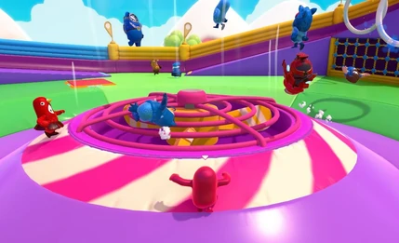

1. Vectors have values for magnitude and direction. Gravity is an important vector for games programming. What *is* gravity? What is the standard magnitude given for earth’s gravity?  
     
   Gravity is a force that is responsible for pulling objects together due to the mass of objects. The standard magnitude is approximately 9.81 m/s2.
2. In the gif below, Mario is held in place by the planet’s force of gravity. Is the gravity vector the same for all positions on the planet’s surface?

Explain your answer.  
  
The gravity vector is not the same for all positions. Although the end point is the same for all positions is the same, the start point is different, thus the direction is different meaning the vector is not the same.





**Question 2**

* Download **GMAPS_Oct_2023_Worksheets_STUDENT** from LMS.
* Open the **Vectors** scene in **VECTORS_worksheet/VectorsPart1**.

Since this is a 2D project, the camera’s projection is set to orthographic.

* Click on **Main Camera** and make sure that **Size** is 5, background colour is white.

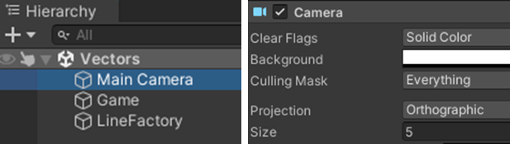

Also set the **MaxLines** property of **LineFactory** to 1.

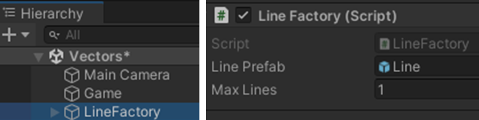

1. In this folder,create a new C# file called **VectorExercises.cs**. Add the function **Question2a()**, as shown below, and call the function in Start().

Make sure to add this script to the **VectorExercises** game object in the scene!

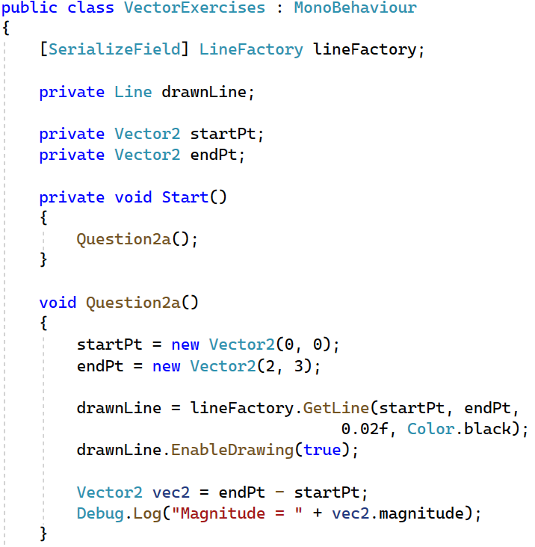

* Refer to the LineDraw documentation and add proper comments to this code.
* This should draw a simple black line, with the start of the line at (0, 0) and the end of the line at (2, 3).

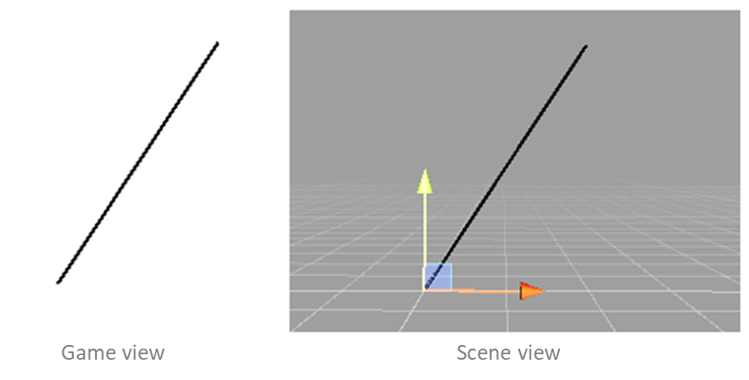

* Run the program a few times, with different start and end points.
* Modify the code so that the **magnitude** of the line is printed in the console.

Hint: look at Unity’s documentation for the Vector2 class.

One problem to solve is how to find the vector from **startPt** to **endPt**.

Hint: look at your lecture slides!

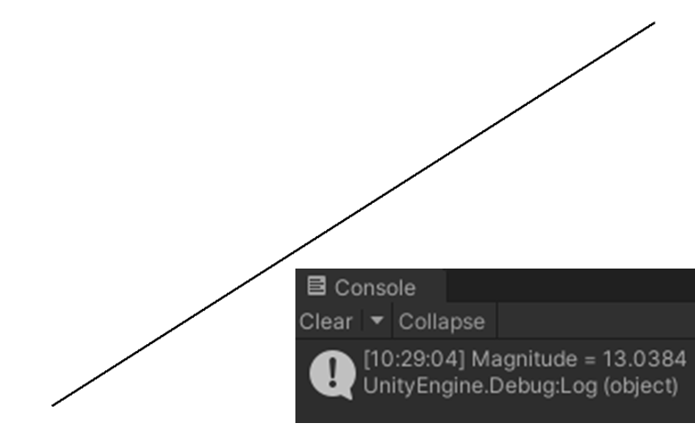

1. Now write another function called **Question2b**. This should have the number of lines to draw as a function argument, e.g. **Question2b (20)**.

The **startPt** and **endPt** of each line must be a random point between **-5** and **5**.

In the Inspector, set the **MaxLines** property of **LineFactory** to however many lines you will draw, e.g. 20.

Your code should be structured like this:

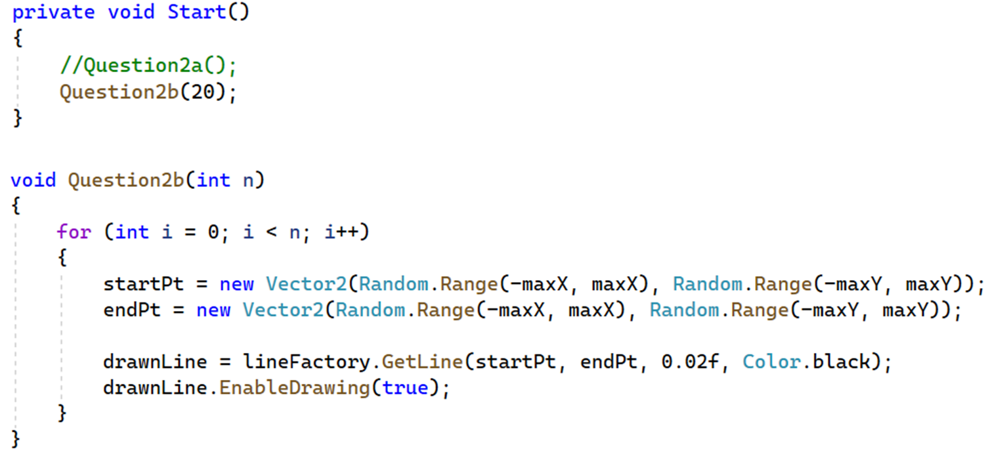

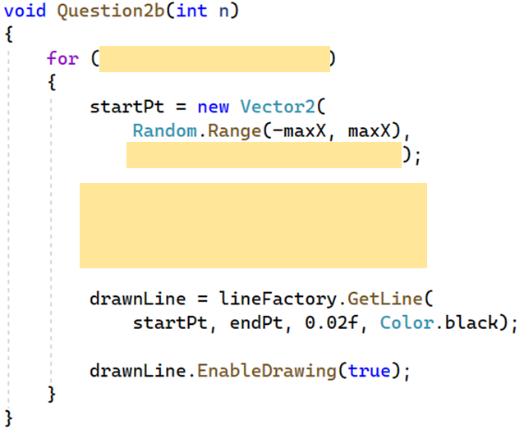

The output should look like (since randomised, it won’t be exactly the same):

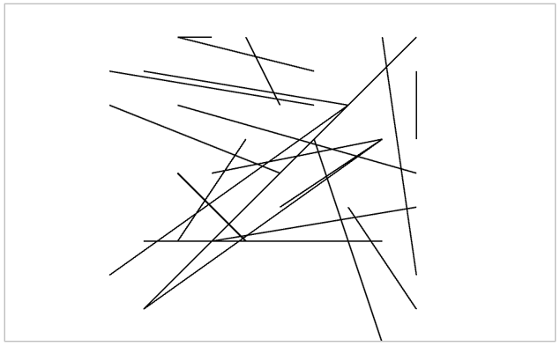

1. **startPt** and **endPt** are currently set within a range of -5 and 5. This means that they are drawn within a 5x5 square on the screen. But it would be good to fill the whole screen with lines.

Modify **Question2b()** to draw random lines across the whole screen!

To do this, you have to calculate the maximum and minimum X and Y values for the screen, i.e. the screen *extents*.

You can do that using this code:

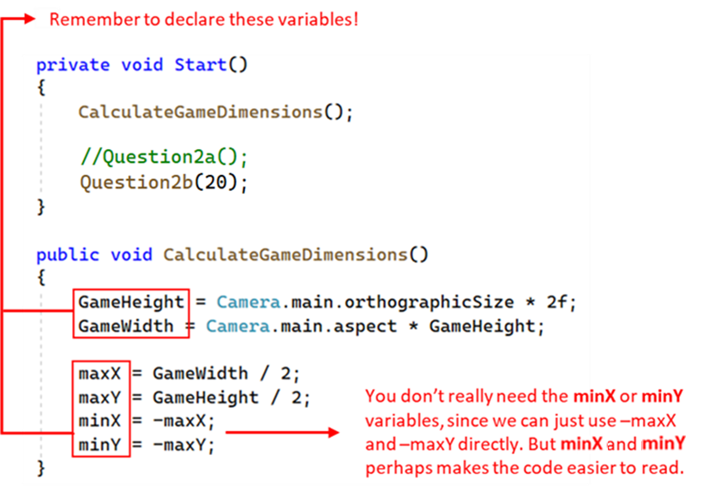

Okay, now you know how to draw lines in your game!

But they are just basic lines.

It would be nice to draw *arrows* to represent vectors (the direction of the arrow being the direction of the vector).

We’ll do that using another plugin, called **DebugDrawingExtension**. This allows us to draw various complex shapes, but only in the Scene view.

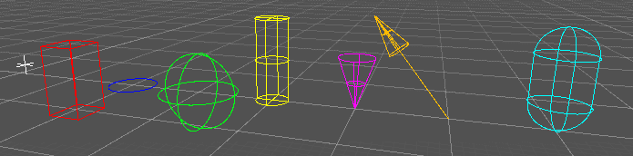

1. It should be in the **GMAPS_Oct_2023_Worksheets_STUDENT** project already, but if not, import **DebugDrawingExtension.unitypackage** from LMS.

The source code for this plugin is in the DebugExtension.cs file, so you can look through it, if you’re curious.

Also look at the **readme** file in the DebugDrawingExtension folder.

Modify your code to draw a single vector arrow, as shown below:

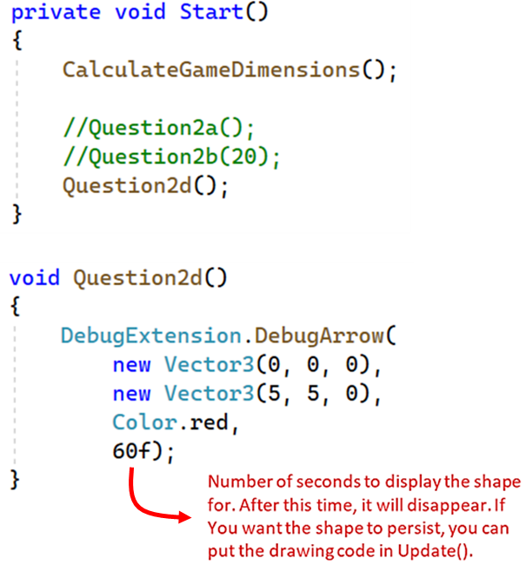

1. Now write a function called **Question2e()**. This should draw a random number of arrows across the screen. The start point for each arrow should be at the origin.

To see the arrows clearly, change the scene view to 3D.

Also, the Z direction has no maximum values (apart from the near and far clip planes). We can set the min and max Z values to anything, so just reuse **-minY** and **minY** for the Z axis min and max values.

The output should look like this (but only in the scene view—you won’t see anything in the game view).





**Question 3**

Inside the **Assets** folder, create a folder called **Math**. Inside Math, create a new C# file called **HVector2D.cs**. Add all the code that we’ve covered so far in the lecture slides. Include all the vector operations you’ve seen:

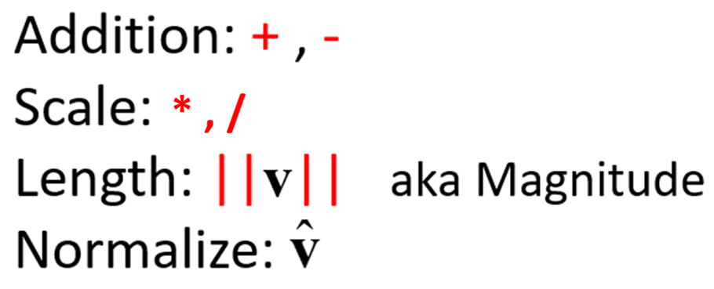

This is a 2D vector class.

One problem, though, is that Unity plugins (like DebugDrawingExtension and LineDraw) work with Unity’s Vector2 class. We can create a Vector2 object from an HVector2D object by simply using the HVector2D object’s **x** and **y** values as arguments to the Vector2 constructor:

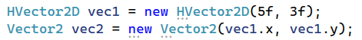

We also need to convert from Unity’s **Vector2** to **HVector2D**. To do this, add another constructor to **HVector2** that takes a **Vector2** object as an argument:

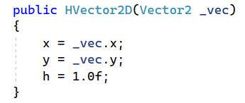

1. Inside **VectorExercises.cs**, create a function called **Question3a()**. Call this function in Start().

Inside this function:

* create an HVector2 object called **a**, with x = 3 and y = 5.
* create an HVector2 object called **b**, with x = -4 and y = 2.
* create an HVector2 object called **c**, which is the sum of **a** and **b**.
* draw each of these vectors, with their starting positions at the origin.
* draw **a** in red, **b** in green, and **c** in white, as shown below.
* then draw **c** again, but this time with its starting position at the head of **b**.

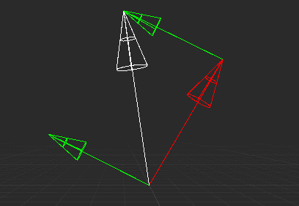

* Find out how to print a float to two decimal places, then add code inside **Question3a()** to print out the magnitudes of each vector to two decimal places.

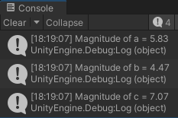

* Modify your code to show **a** *minus* **b**. Draw **-b** from the head of **a**, as shown below.

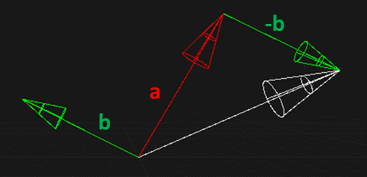

1. Inside **VectorExercises.cs**, create a function called **Question3b()**. Call this function in Start().

* Create an **HVector2D** object called **a**, with x = 3 and y = 5
* Set a **b** vector to **a** scaledby 2.
* Draw **a** from the origin.
* Draw **b** offset 1 unit along x from the origin.

The output should look this:

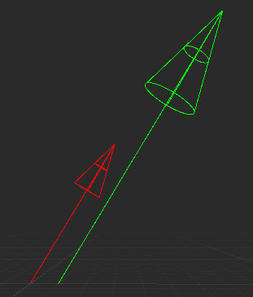

*You might wonder why we need to use Unity’s Vector3 class if we have our own HVector2 class.*

*As mentioned earlier, this is because the Unity API (which is also used by Unity plugins) uses Unity’s vectors. So, we convert to a Unity vector when we want to draw a vector, but not for all the behind-the-scenes vector math.*

*If we were using a different language, such as JavaScript or Python, we wouldn’t have to do this.*

* Modify your code to show **a** *divided by* 2.

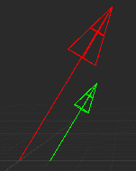

1. Inside **VectorExercises.cs**, create a function called **Question3c()**. Call this function in Start().

* Create an HVector2 object called **a**, with x = 3 and y = 5
* Draw **a** from the origin.
* Draw **a** *normalised* offset 1 unit along x from the origin.

The output should look like:

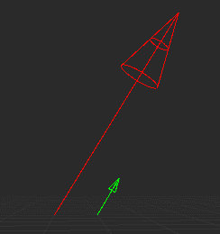

Print the magnitude of the normalised **a** vector.

The magnitude should (of course) be 1.

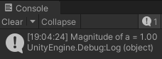

1. Look at the Projection function. Fill in the missing code to draw the projection of vector **v2** onto vector **v1**, as shown below:

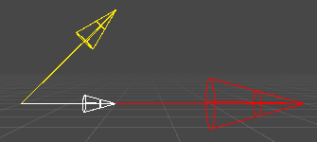



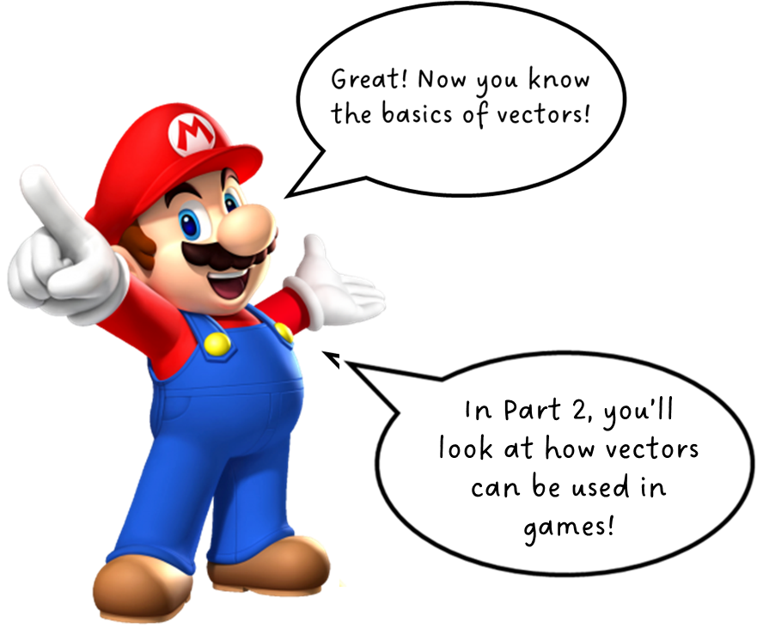

**PART 2: Vectors in Games**

**Question 4**

Look at the animation below from Super Mario Galaxy. How is Mario able to run around the surface of the planet?

It obviously has something to do with the direction of gravity acting on Mario.

 

You can see this in the second animation.

The blue arrow (at the astronaut’s feet—look closely!) is a vector that represents the astronaut’s horizontal movement relative to the moon’s surface), and the red arrow represents the direction and magnitude of the gravity that acts on the astronaut.

1. Download from LMS, and then import, **mario_galaxy_exercise.unitypackage**. This includes the moon sprite and the animated [astronaut](https://assetstore.unity.com/packages/2d/characters/2d-character-astronaut-182650).

Make sure that the **DebugDrawingExtension** is already in the project folder.

Create a new C# script called **Mario.cs**. The code is listed below, with blanks that you have to fill. Add this to the astronaut game object.

After the code listing, you’ll find a few hints.

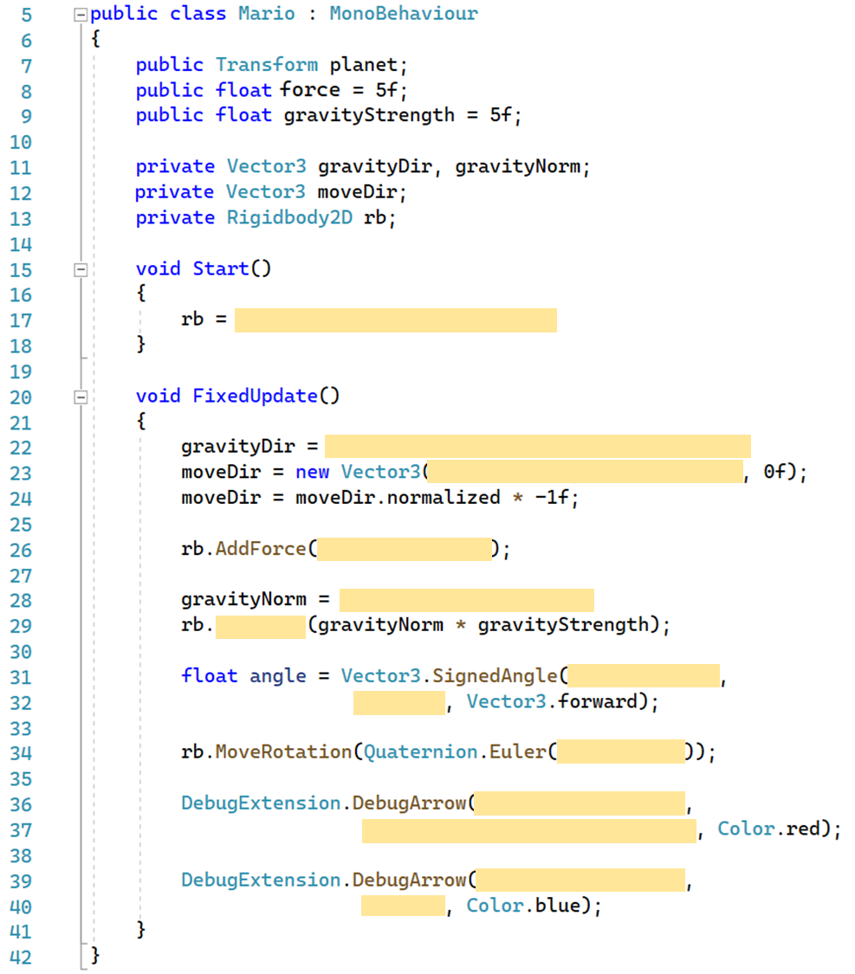

**Some hints**



* **Line 17**: You have to store a reference to the game object’s RigidBody2D component. You should know how to do this!
* **Line 22**: Here you must calculate the vector that represents the moon’s gravity. You know how to calculate a vector between two points now, so all you have to do is figure out *which* points, and which direction! (If unsure, see the diagram below.)
* **Line 23**: You must calculate the move vector for the astronaut, i.e. the astronaut’s horizontal direction of movement relative to the planet.

Look at the diagram below:

First, how to find a vector **b** that is perpendicular to another vector **a**?

For 2D vectors (with z = 0), this is easy! Just switch the x and y coordinate values, and then set the new x to be the negative of itself.

So, for vector **a** below, the coordinate values are (-x, -y).

To find the perpendicular vector **b**, set the x and y values to (-y, x). Note that the x value for **a** is negative, so it becomes positive when switched.

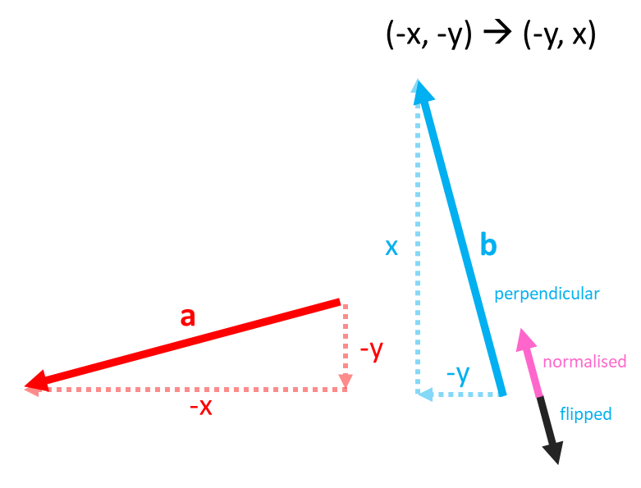

The perpendicular vector **b** points up and to the left (north-west).

But to make the astronaut move clockwise, we have to flip **b** to make it point down and to the right (south-east).

We flip a vector by multiplying it by -1.

Note that since we only care about direction, we normalise the perpendicular vector first. We also need to multiply this normalised vector by **speed**.

It’s important to understand that the direction of vector **a** affects the direction of perpendicular vector **b**. This is shown in the diagram below, where **a** points up and to the right. The direction of the perpendicular vector **b** is reversed compared to the first diagram.

In the diagram above, the tail of **a** is the surface of the moon, and the head of **a** is the centre of the moon.

This represents the moon’s gravity, so should obviously point inwards.

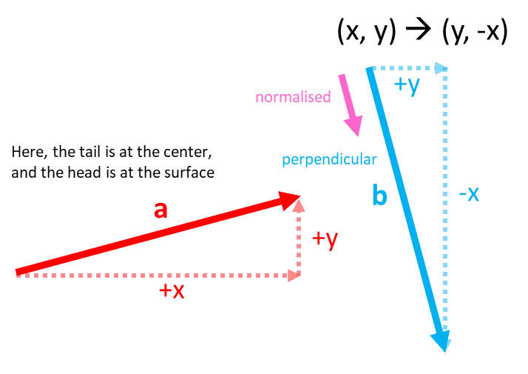

The diagram below shows different directions for **a** (red) and the resultant direction of perpendicular vector **b** (blue).

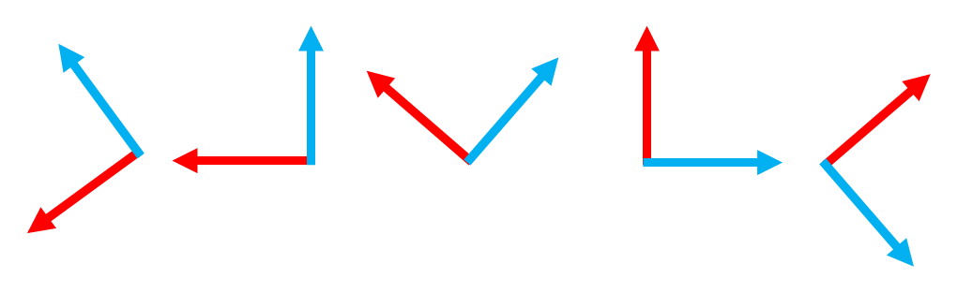

* **Line 24**: This is where we flip the normalised perpendicular vector, as we just discussed above.
* **Line25**: Add a force in the move direction with a magnitude of **force** (see line 8).
* **Line 28**: Normalise the gravity vector. This is so that we can set its magnitude using **gravityStength** (line 9).
* **Line 29**: Now apply gravity. Note that the astronaut’s Rigidbody2D has its **Gravity Scale** property set to 0. This is because we are applying our own gravity.
* **Line 31**: We need to rotate the astronaut sprite so that it looks like it is standing on the surface of the moon. Unity’s Vector3 **SignedAngle** function calculates the angle between two vectors.
* **Line 34**: Rotate the astronaut. Note that we rotate the Rigidbody2D component, not the gameobject.
* **Line 36 and 39**: Draw the arrows for gravity and move direction.



1. Now create a new C# script called **MarioHVector2D**. Try to rewrite the Mario script but using your HVector2D class.

Add this script to the astronaut object. Remember to set the planet property in the Inspector! Then deactivate the original Mario script and activate MarioHVector2D**.**



**Question 5 (optional after class activity)**

The exercise above is very simple, just to show how vectors can be used to find a solution to the Mario Galaxy problem.

A better solution is shown in this short (13 minutes) [YouTube video](https://www.youtube.com/watch?v=sK8FrL3ZJi0). Go through the video and implement the project, using the astronaut assets.

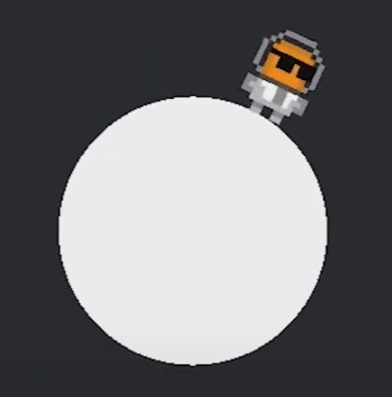

This is an optional exercise since we don’t have time to go through very long tutorials in class. But you should get into the habit of exploring how different game mechanics and other game features are implemented at a more complex level.

It’s also good to go through multiple tutorials to compare how different programmers solve the same problems.

**PART 5: Dot & Cross Product**

Now we’ll look at the dot and cross product.

[](https://fifaforums.easports.com/en/discussion/532738/passing-post-patch)

**Question 6 – Dot product**

No, we won’t be making a AAA soccer game. So why show FIFA?

Well, underlying every game is a lot of basic algorithms that you need to know! For example, how to let the player kick a ball to another player, but without needing pinpoint accuracy.

What if you’re not pointing exactly at the target player you want to pass the ball to?

Should you miss, or should the game be more forgiving and help you make the shot?

Look at this:



If the player faces a particular direction and passes the ball, which teammate should it go to if the player doesn’t perfectly point towards the intended target?

Probably the teammate closest in direction to the player’s forward direction (shown in red as the player object rotates to look at the other players).

To do this, we need to calculate and compare two angles, θ1 and θ2:

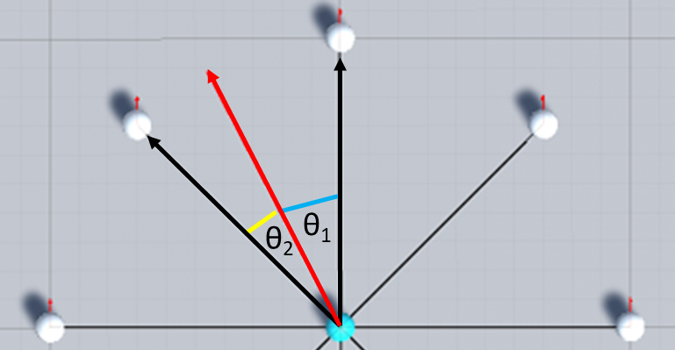

Since θ2 is less than θ1, the ball should be passed to player B. But how can we implement this?

You should know by now that the direction from the player to A, and the direction from the player to B, are both vectors.

Also, the direction that the player is facing is a vector.

So our problem becomes:



Before we can solve this, we must know how to calculate the vector from the player to A, and from the player to B.

**Part 1**

1. Create a new folder in **VECTORS_worksheet** called **Soccer**. Add a new scene with 3 game objects:

* a plane for the ground, called **Pitch**, at (0, 0, 0)
* a capsule game object, called **Captain**, at (0, 1, 0)
* a capsule game object, called **Player1**, at (-10, 1, 10)

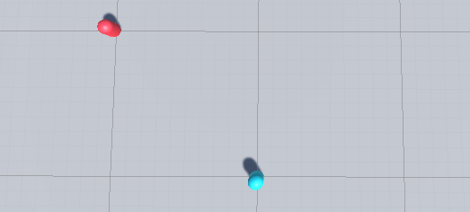

1. Create a script called **Player.cs**, and add this to **Captain** and **Player1**.

public class Player : MonoBehaviour

{

public bool IsCaptain = true;

public Player OtherPlayer;

void Update()

{

if(IsCaptain)

{

// Code to draw the arrow

}

}

}

Now **implement** code to draw an arrow that represents the vector from Captain to Player1.

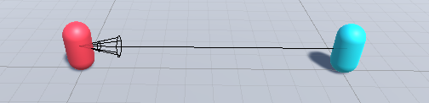

Move both game objects around in the scene view. The vector between them changes, and so the arrow changes, too.



**Notice that we’re using what you learned earlier, to calculate a vector between two objects (actually, between two positions).**

**You need to understand the basics before you can move on to solving more interesting problems—but really, they’re the same problem!**

**You also should also see that being able to draw an arrow to represent a vector in the scene view is very useful for debugging.**

Now we need to know which way the Captain object is facing. This is easy!

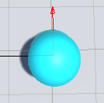Every game object has a Transform component. And the Transform class has a [forward](https://docs.unity3d.com/ScriptReference/Transform-forward.html) property, which is a vector that represents the direction the object is facing in world space.

1. Draw a blue arrow to represent the Captain’s forward vector.

We know how to get the Captain object’s forward vector, and also how to calculate the vector from Captain to Player1.

Now we have to calculate the angle between these vectors. To do that, we use the vector **dot product**.

**Remember that the dot product can be used to calculate the angle between two vectors.**

1. Add code to print the angle between Captain’s forward vector and the vector from Captain to Player1’s position, and vice versa.

**Part 2**

1. Let’s add some more players.

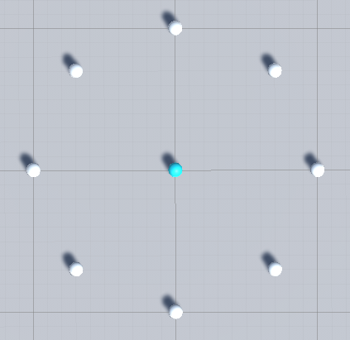

Create a new script called **SoccerPlayer.cs**.

Select both Captain and Player 1. Remove the Player script, and add **SoccerPlayer** to them both.

Then duplicate Player 1 to create 7 other players and arrange them all in a circle around Captain.

Create a new white material and make the other players all white. Also, make sure that Captain’s **IsCaptain** checkbox is ticked, and unticked for all the others.

**SoccerPlayer.cs** should look like this:

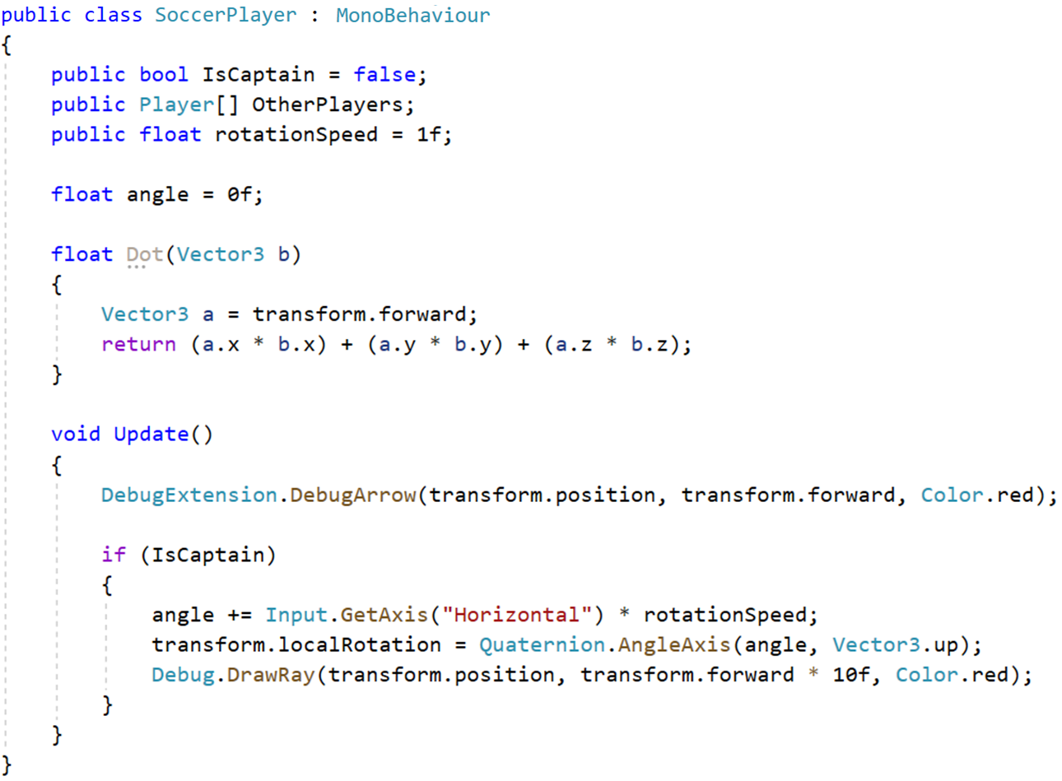



Run the scene, and press the left and right arrow keys.

Captain should rotate, and also draw a ray of length 10 units along its forward direction.



The rotation is implemented using Unity’s **Quaternion** class.

A quaternion is a complex mathematical object.

The **AngleAxis** function creates a rotation which rotates **angle** degrees around **axis** (this is a vector which acts as the axis of rotation):



We won’t look at the Quaternion class in detail, but we will make use of some of the useful functions it provides.

Also note that the vector for drawing the ray is defined as:

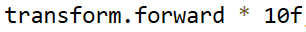

**transform.forward** is a **unit vector** (length = 1), so if it’s multiplied by a number, **n**, it will have length n units.

In this case, it’s multiplied by 10, so the vector has a length of 10 units.

The next problem isn’t physics or math, but how can we make every player know about every other player?

Note that **OtherPlayer** is now an [*array*](https://www.w3schools.com/cs/cs_arrays.php) of Player objects:



Obviously, this will store [references](https://www.tutorialsteacher.com/csharp/csharp-value-type-and-reference-type) to the other players in the scene.

We need a way to get those references.

1. Add a **Start** function:

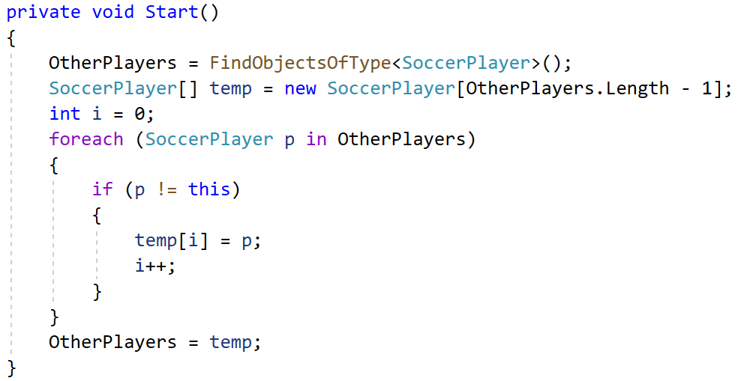

At the end of Start, print out the number of items in **OtherPlayers**. There should be 8.



**Continued …**

Now delete all the code in **Start**, and put this single line instead:



1. Now add a function called **DrawVectors**.

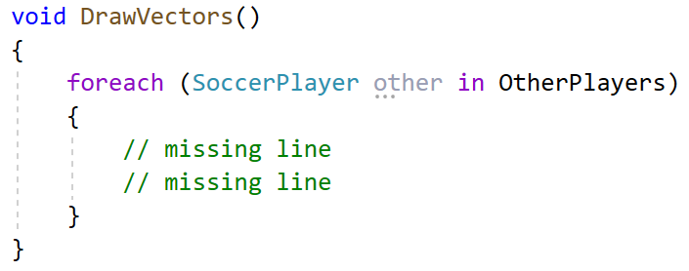

**DrawVectors** should draw a ray from each instance of SoccerPlayer to every other SoccerPlayer object in **OtherPlayers**.

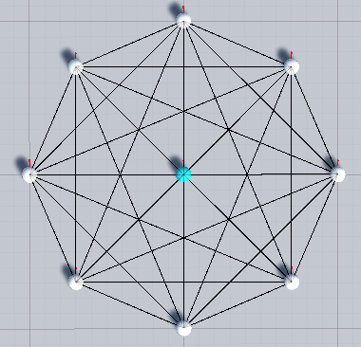

Where should you call DrawVectors to make sure that the rays are drawn continuously as the scene plays?

**Now you know how to get a reference to all the other SoccerPlayer objects in the scene, and how to filter them using a LINQ query.**

Finally, we’ve got to the real problem we’re trying to solve, which is to find the closest player by rotation to pass the ball to.

Well, almost.

Before we get to that, I want to make sure you understand some other non-physics or math code.

If you dynamically generate a sequence of **n** numbers, how can you find the smallest?

1. Add this temporary function, and call it in **Start**. Add code to find the minimum of a sequence of 10 random numbers.

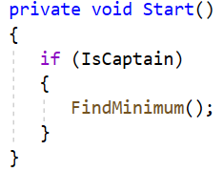

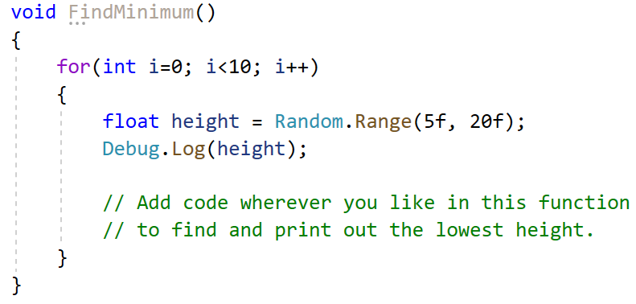

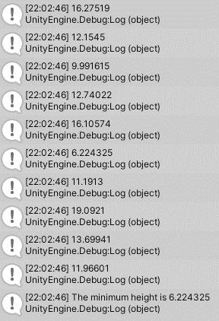

But we don’t want to find the minimum of a sequence of random numbers.

We want to find the minimum angle that Captain must rotate to face one of the other players. The ball should then be passed to the player with the smallest angle.

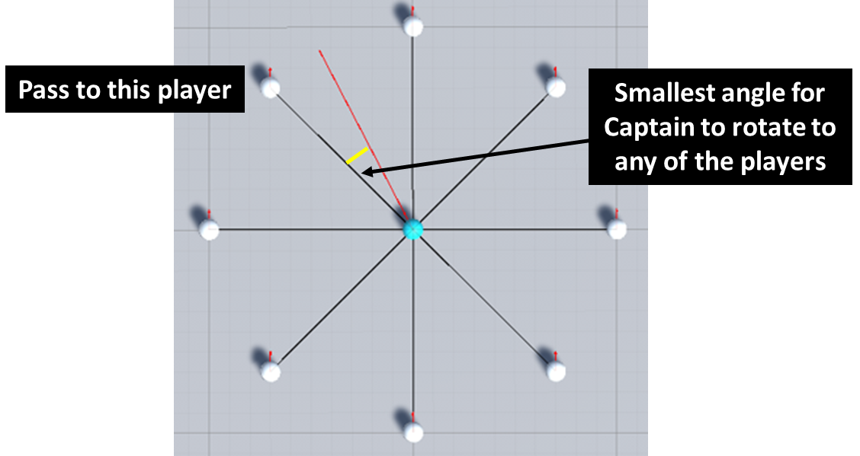

1. Add this function and complete the missing code.

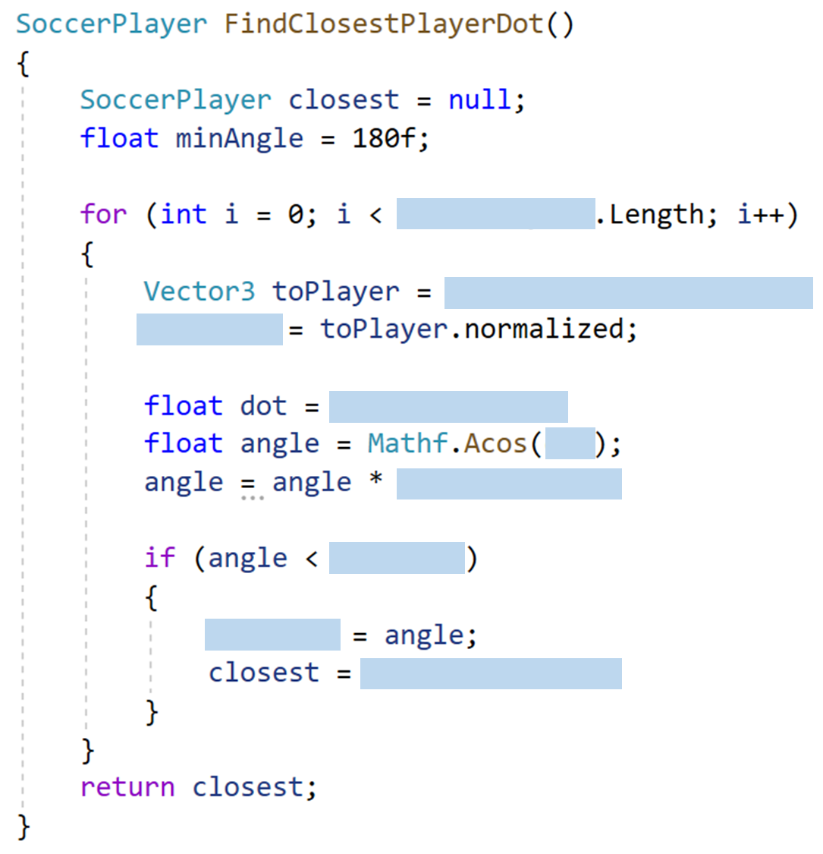

1. Add the missing code the Update function.

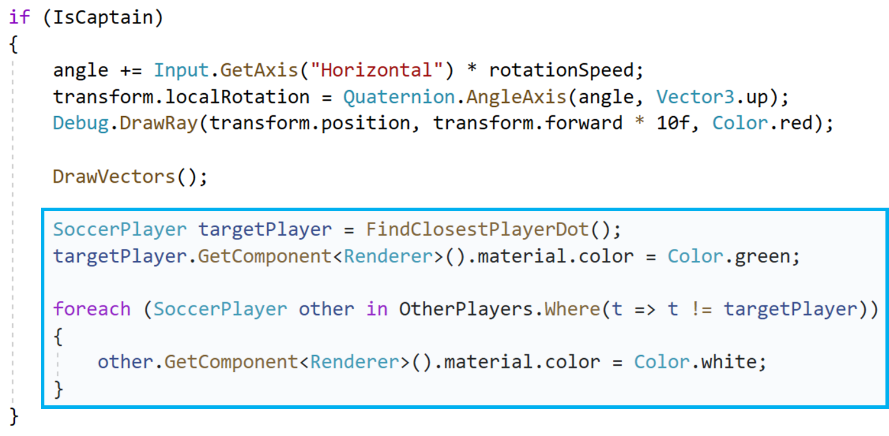

Play the scene, and rotate the Captain!



**Now you know how to solve a real game problem using some fairly complicated vector math. You shouldn’t be afraid of math. As a game programmer, math is your friend, and most of it isn’t so hard … really.**

